**MNTSDEV Backlog and Use Case Diagram for**

**DOST STARBOOKS: Whiz Challenge**

Project Documentation Submitted to the Faculty of the

School of Computing and Information Technologies

Asia Pacific College

In Partial Fulfillment of the Requirements for

Systems Analysis and Detailed Design

MSYADD1

Submitted by:

**Dumbrique, Kelly (Team Leader)**

**Gercan, Arcielle Marie (Member)**

**Quianzon, Shandrae Lois (Member)**

**Salipande, Janice Maxene (Member)**

G06 NEXUS – SF 231

Submitted to:

**Mr. Jose Eugenio L. Quesada**

Course Instructor

August 2025

1st Term

A.Y. 2025 – 2026

**BACKLOG FROM MNTSDEV**

*(Our team didn’t use a backlog at that time; instead, we worked with a Kanban board.)*

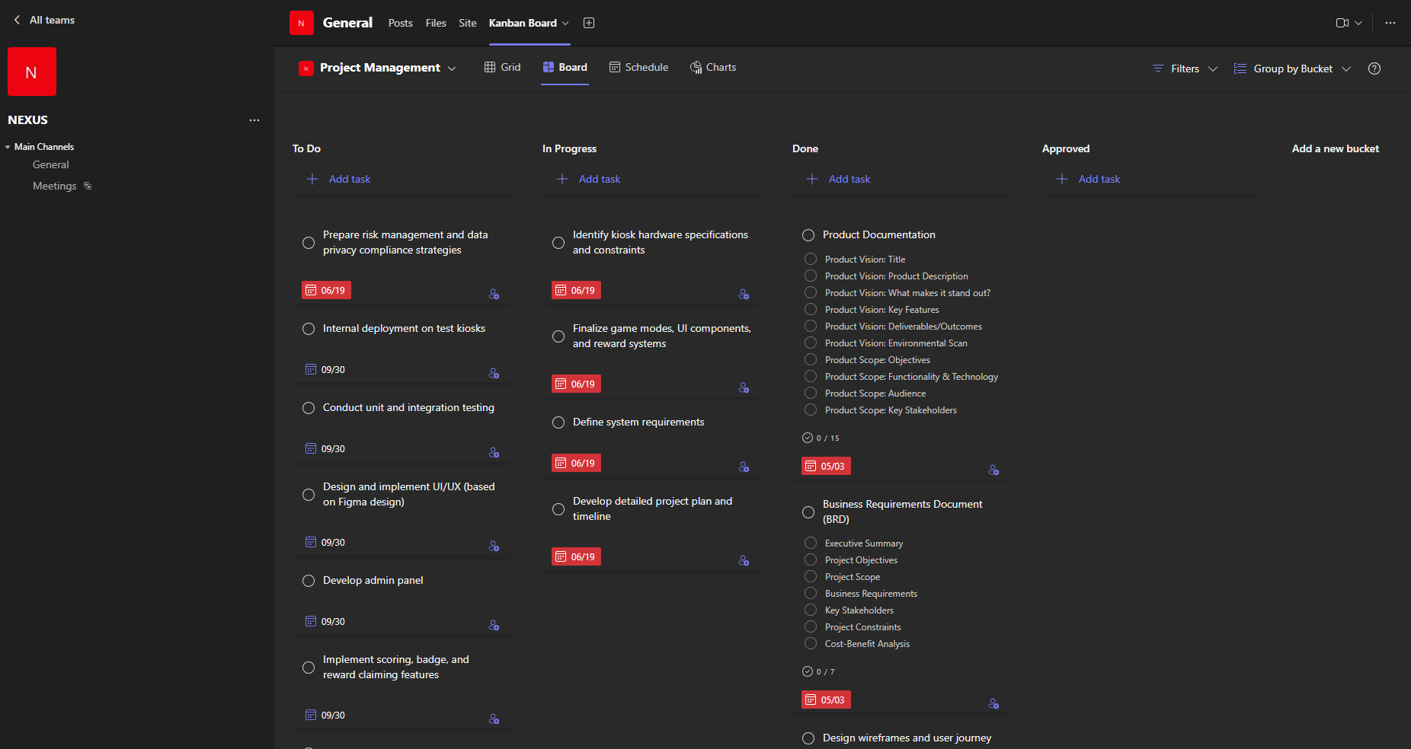

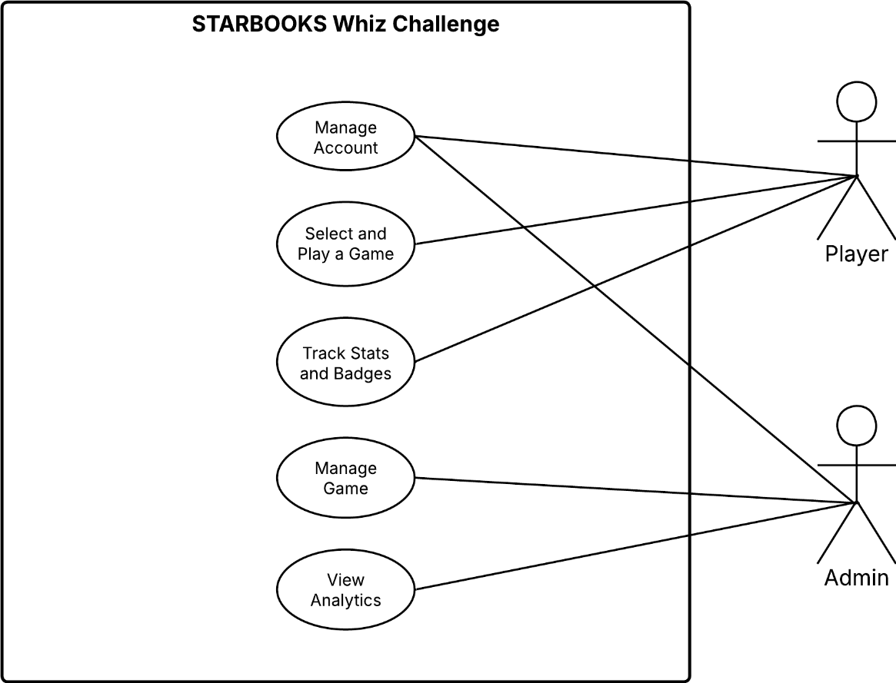**USE CASE DIAGRAM**

**FULLY DRESSED USE CASE**

**Register Account**

|  |  |
| --- | --- |
| **Use Case ID** | UC-01 |
| **Use Case Name** | Register Account |
| **Created by** | Janice Maxene Salipande |
| **Date Created** | 06-04-2025 |
| **Purpose** | To allow new players to register and create an account for  accessing the system. |
| **Requirement**  **Traceability** | BR-01 |
| **Priority** | High |
| **Preconditions** | * The player has not yet registered in the system. |
| **Postconditions** | * A new player profile has been created and saved. |
| **Actors** | Player |
| **Include** | * Display Terms and Conditions * Setup Account |
| **Extends** | None |
| **Flow of Actions** | **Basic Flow:**   1. Player clicks on the "Register" button. 2. System displays terms and conditions; player reads and accepts. 3. Player selects an avatar. 4. Player enters first name, last name, username, and password. 5. Player selects a player category, sex, region, province, and city. 6. Player clicks "Submit" to complete the registration. 7. System saves the profile and confirms registration success.   **Alternative Flows**  ***2a Player Declines Terms and Conditions:***   * 1. The player clicks "Register here."   2. The system displays the Terms and Conditions.   3. The player does not click "Accept."   4. The system cancels the registration process and returns the player to the welcome screen.   ***6a Missing or Incomplete Fields:***   * + 1. The player fills in the form and clicks “Submit.”     2. The system detects one or more empty or invalid fields (e.g., missing username, invalid password).     3. The system displays an error message indicating the problematic fields.     4. The player corrects the input and clicks “Submit” again. |

|  |  |
| --- | --- |
|  | 1. The system proceeds with registration if all inputs are valid.   ***6b Username Already Exists:***   * 1. The player enters a username that already exists in the database.   2. The system displays an error message: “Username already taken.”   3. The player edits the username to a new, unique one.   4. The player clicks “Submit.”   5. The system proceeds with registration. |

**Login**

|  |  |
| --- | --- |
| **Use Case ID** | UC-02 |
| **Use Case Name** | Login |
| **Created by** | Janice Maxene Salipande |
| **Date Created** | 06-04-2025 |
| **Purpose** | To allow registered players and admins to access the system. |
| **Requirement**  **Traceability** | BR-02, BR-11 |
| **Priority** | High |
| **Preconditions** | * The user must be registered and have valid login credentials. |
| **Postconditions** | * The user is logged in and redirected to the homepage. |
| **Actors** | Player, Admin |
| **Include** | None |
| **Extends** | * Forgot Password |
| **Flow of Actions** | **Basic Flow:**   1. The user opens the system. 2. The login form is displayed asking for username and password. 3. The user inputs their registered username and password. 4. The system verifies the credentials against stored data. 5. If the credentials are correct, the user is logged in. 6. The system redirects the user to the homepage.   **Alternative Flows**  ***3a Invalid Credentials:***   * 1. User inputs an incorrect username or password.   2. System shows an error message indicating invalid login.   3. User is prompted to re-enter correct credentials.   ***3b Missing or Incomplete Fields:***   * + 1. User clicks the login button without filling in one or both fields.     2. System highlights the missing fields and displays a “Please complete all fields” message. |

|  |  |
| --- | --- |
|  | 3. User fills in the missing information and retries login. |

**Edit Profile**

|  |  |
| --- | --- |
| **Use Case ID** | UC-03 |
| **Use Case Name** | Edit Profile |
| **Created by** | Janice Maxene Salipande |
| **Date Created** | 06-04-2025 |
| **Purpose** | To allow players to update their personal information and/or  change their password. |
| **Requirement**  **Traceability** | BR-03 |
| **Priority** | Medium |
| **Preconditions** | * Player must be logged into the system. |
| **Postconditions** | * Player's updated profile information or new password is saved and reflected across the system. |
| **Actors** | Player |
| **Include** | None |
| **Extends** | * Change Password |
| **Flow of Actions** | **Basic Flow:**   1. Player clicks the “Edit Profile” button located near their username on the homepage. 2. System displays the editable profile form with pre-filled existing data. 3. Player updates one or more fields (e.g., avatar, name, category, sex, region, province, city). 4. Player may also click the “Change Password” option. 5. Player clicks the “Save” button. 6. System validates the updated information. 7. If valid, system saves the new details to the local database. 8. A confirmation message is displayed: “Profile updated successfully.” 9. System reflects the changes immediately on the homepage and other relevant areas.   **Alternative Flows**  ***1a Player Cancels Edit:***   * 1. Player clicks the “Edit Profile” button.   2. After viewing the form, the player decides not to make any changes.   3. Player clicks a “Cancel” button.   4. System discards any unsaved changes and returns the player to the homepage.   ***5a Validation Errors:*** |

|  |  |
| --- | --- |
|  | 1. Player clicks the “Save” button with one or more invalid or incomplete fields (e.g., missing required fields or invalid characters). 2. System highlights the fields with errors and displays an appropriate message (e.g., “Username must be unique” or “Please select a city”). 3. Player corrects the issues and resubmits.   ***5b Save Failure:***   * 1. After the player submits valid inputs, a local storage failure occurs (e.g., full storage, write error).   2. The system displays an error message: “Failed to save changes. Please try again.”   3. Player is prompted to retry or cancel. |

**Play Whiz Challenge**

|  |  |
| --- | --- |
| **Use Case ID** | UC-04 |
| **Use Case Name** | Play Whiz Challenge |
| **Created by** | Janice Maxene Salipande |
| **Date Created** | 06-04-2025 |
| **Purpose** | To allow the player to play a solo quiz game, earn badges, and view performance stats. |
| **Requirement Traceability** | BR-04 |
| **Priority** | High |
| **Preconditions** | * Player must be logged in. |
| **Postconditions** | * Game results (correct answers, wrong answers, average time per question) are displayed to the player. * Player may earn a badge if all answers are correct. * Player stats are updated. |
| **Actors** | Player |
| **Include** | None |
| **Extends** | * Earn Badge |
| **Flow of Actions** | **Basic Flow:**   1. Player clicks the “Whiz Challenge” from the homepage. 2. System prompts the player to select a category: Science or Math. 3. Player selects the desired difficulty level: Easy, Average, or Difficult. 4. Player starts the quiz game. 5. System displays one question at a time, with answer options and a countdown timer. 6. Player selects an answer. 7. System provides immediate feedback: correct or incorrect. 8. Steps 5–7 repeat until all questions are answered. 9. System evaluates the results. |

|  |  |
| --- | --- |
|  | 1. If all answers are correct, player earns a badge for that difficulty level. 2. System displays session performance stats: number of correct answers, wrong answers, and average time per question. 3. Player returns to the homepage or selects another game.   **Alternative Flows**  ***2a Player Cancels Category Selection:***   * 1. Player opens the category selection screen but decides not to proceed.   2. Player clicks the “Back” button.   3. System returns the player to the homepage without starting the quiz.   ***5a Player Times Out on a Question:***   * + 1. Player does not answer the question within the allowed time.     2. System automatically marks the question as incorrect.     3. System proceeds to the next question.   ***5b Player Closes Game Prematurely:***   * + - 1. During the quiz, player exits or closes the game (intentionally or accidentally).       2. System records the session as incomplete.       3. No badge or stats are saved.       4. Player must restart the quiz from the beginning. |

**View Badges**

|  |  |
| --- | --- |
| **Use Case ID** | UC-05 |
| **Use Case Name** | View Badges |
| **Created by** | Janice Maxene Salipande |
| **Date Created** | 06-04-2025 |
| **Purpose** | To allow the player to view earned badges and claim rewards if criteria are met. |
| **Requirement Traceability** | BR-05 |
| **Priority** | High |
| **Preconditions** | * Player must be logged in. * Player must have played game modes and earned badges. |
| **Postconditions** | * Player either views current badge progress or successfully claims a reward. |
| **Actors** | Player |
| **Include** | None |
| **Extends** | * Claim Reward |

|  |  |
| --- | --- |
| **Flow of Actions** | **Basic Flow:**   1. Player clicks the “Your Badges” button on the homepage. 2. System displays badge collections grouped by difficulty level. 3. Player views which badges they’ve earned and which ones   are missing.   1. For any difficulty level with 3 badges (indicating full   completion), a “Claim” button is enabled.   1. Player clicks the “Claim” button. 2. System confirms reward eligibility and updates the reward   status to “Claimed”.   1. System may also notify the admin (for DOST fair setups) for physical reward distribution. 2. Player exits the reward section or continues using the system.   **Alternative Flows**  ***3a Player Has Incomplete Badge Set:***   * 1. Player views a difficulty level with less than 3 badges.   2. “Claim” button is disabled and shows “Locked.”   3. Player can choose to continue playing to earn missing badges.   ***5a Player Tries to Claim Already Claimed Reward:***   * + 1. Player clicks on a previously claimed reward.     2. System shows a message: “Reward already claimed.”     3. System disables re-claiming for the same reward.   ***5b System Fails to Update Reward Status:***   * + - 1. Player clicks “Claim” but due to a technical error, the claim   fails.   * + - 1. System shows an error message: “Failed to claim reward. Please try again later.”       2. Player may retry or contact staff at the exhibit/fair. |

**Play Whiz Memory Match**

|  |  |
| --- | --- |
| **Use Case ID** | UC-06 |
| **Use Case Name** | Play Whiz Memory Match |
| **Created by** | Janice Maxene Salipande |
| **Date Created** | 06-04-2025 |
| **Purpose** | To allow the player to play the memory card matching game. |
| **Requirement Traceability** | BR-06 |
| **Priority** | High |
| **Preconditions** | * Player must be logged in. |

|  |  |
| --- | --- |
| **Postconditions** | * Game result (time taken, best time) is displayed to the player. * Player stats are updated. |
| **Actors** | Player |
| **Include** | None |
| **Extends** | None |
| **Flow of Actions** | **Basic Flow:**   1. Player clicks on the "Whiz Memory Match" game mode from the homepage. 2. System displays the difficulty selection screen:    * Easy: 5 pairs    * Average: 6 pairs    * Difficult: 7 pairs 3. Player selects a difficulty level. 4. System generates and shuffles the card grid based on selected difficulty. 5. Game screen loads, showing the timer, score, moves, and card grid. 6. Player begins clicking cards to reveal and match pairs. 7. System:    * Records number of moves    * Starts timer upon first click    * Records score for correct matches 8. Once all pairs are matched:    * System stops the timer    * Displays the game summary (time taken, best time)    * Updates the best time if the current time is faster than previous best 9. Player can choose to replay, or return to homepage.   **Alternative Flows**  ***4a System Fails to Load Cards:***   * 1. Upon selecting a difficulty, the game screen fails to load due to a glitch.   2. System shows error: “Failed to load memory cards. Please try again.”   3. Player is redirected to the difficulty selection screen to try again.   ***5a Player Closes Game Before Completion:***   1. Player starts a game but closes the app or navigates away. 2. System does not save partial progress. 3. Player must restart the game from the beginning.   ***8a New Time Is Not Faster Than Previous Best:***   * + 1. Player finishes the game with a time slower than their best for that level. |

|  |  |
| --- | --- |
|  | 2. System updates the current session’s stats but does not  change the best time. |

**Play Whiz Puzzle**

|  |  |
| --- | --- |
| **Use Case ID** | UC-07 |
| **Use Case Name** | Play Whiz Puzzle |
| **Created by** | Janice Maxene Salipande |
| **Date Created** | 06-04-2025 |
| **Purpose** | To allow the player to play the jigsaw-style puzzle game. |
| **Requirement**  **Traceability** | BR-07 |
| **Priority** | High |
| **Preconditions** | * Player must be logged in. |
| **Postconditions** | * Game result (time taken, best time) is displayed to the player. * Player stats are updated. |
| **Actors** | Player |
| **Include** | None |
| **Extends** | None |
| **Flow of Actions** | **Basic Flow:**   1. Player clicks on the "Whiz Puzzle" game mode from the homepage. 2. System displays the difficulty selection screen:    * Easy: fewer puzzle pieces    * Average: moderate puzzle pieces    * Difficult: more puzzle pieces 3. Player selects a difficulty level. 4. System displays available categories/themes (e.g., Solar System, Scientists, Human Body, Animals, Geometry, Random/Shuffle). 5. Player selects a category/theme. 6. Puzzle game screen loads based on selected difficulty and theme. 7. Timer starts when the player moves the first piece. 8. Player arranges pieces to complete the puzzle. 9. Once the puzzle is completed:    * System stops the timer    * Displays time taken to solve    * Compares and updates best time if beaten 10. Player can choose to replay, or return to homepage.   **Alternative Flows**  ***5a Player Selects Random/Shuffle Category:*** |

|  |  |
| --- | --- |
|  | 1. Player selects “Random/Shuffle” instead of a specific   theme.   1. System randomly selects a category and loads the corresponding puzzle.   ***6a Puzzle Fails to Load:***   * 1. System fails to load the puzzle due to technical issue.   2. Error message appears: “Unable to load puzzle. Please try again.”   3. Player is redirected to category selection screen.   ***8a Player Leaves Game Mid-Session:***   * + 1. Player exits or navigates away from the game before completing it.     2. System does not save incomplete puzzle session.     3. Player must restart the puzzle if returning.   ***9a Player Does Not Beat Best Time:***   * + - 1. System detects current session time is slower than previous best.       2. System updates the current session’s stats but does not   change the best time. |

**Play Whiz Battle**

|  |  |
| --- | --- |
| **Use Case ID** | UC-08 |
| **Use Case Name** | Play Whiz Battle |
| **Created by** | Janice Maxene Salipande |
| **Date Created** | 06-04-2025 |
| **Purpose** | To enable players to engage in a 1v1 quiz battle by creating or  joining a game using a game code. |
| **Requirement**  **Traceability** | BR-08 |
| **Priority** | High |
| **Preconditions** | * Player must be logged in. |
| **Postconditions** | * Battle result is displayed to the player. * Player stats are updated. |
| **Actors** | Player |
| **Include** | * Create Battle * Join Battle via Game Code |
| **Extends** | None |
| **Flow of Actions** | **Basic Flow:**   1. Player clicks on the "Whiz Battle" game mode from the homepage. 2. System displays two options:    * Create Battle    * Join Battle 3. If player selects Create Battle: |

|  |  |
| --- | --- |
|  | * System prompts the player to select a category (Science or Math). * Player selects a difficulty level (Easy, Average, Difficult). * System generates a unique game code and   displays a “waiting for opponent” screen.   * Second player joins using the code. * Once both players are ready, the battle begins. |
| 1. If player selects Join Battle:    * Player enters the game code received from another player.    * System validates the code and connects both players.    * Battle starts once both players are ready. 2. During the battle:    * A series of questions appear, same as in the solo quiz.    * After each question, a progress bar displays which player is leading. 3. After final question:    * System calculates total scores.    * Displays final result: Victory/Defeat/Draw.    * Updates player stats (win/loss record, match history, etc.).   **Alternative Flows**  ***3a Opponent Fails to Join Created Battle:***   1. Player creates a battle and waits for an opponent. 2. Opponent does not join within a set time (e.g., 2–3 minutes). 3. System prompts: “No opponent found. Try again?” 4. Player may retry or return to homepage.   ***4a Invalid Game Code Entered:***   * 1. Player attempts to join a battle using an invalid or expired code.   2. System shows error: “Invalid game code. Please check and try again.”   3. Player can re-enter code or return to homepage.   ***5a Connection Interrupted During Battle:***   * + 1. One player disconnects mid-game due to connectivity issue.     2. System pauses the game and attempts reconnection.     3. If reconnection fails, match ends with status “incomplete”.     4. Stats are not updated; player is redirected to homepage.   ***5b Player Exits Before Match Ends:***   * 1. Player manually exits during battle.   2. System counts it as a forfeit.   3. Opponent wins by default; stats updated accordingly.   ***6a Both Players Get Equal Scores:***   * + - 1. After final question, system detects a tie. |

|  |  |
| --- | --- |
|  | 1. Message displayed: “It’s a draw! Great match!” 2. Match is logged with "draw" status. |

**View Stats**

|  |  |
| --- | --- |
| **Use Case ID** | UC-09 |
| **Use Case Name** | View Stats |
| **Created by** | Janice Maxene Salipande |
| **Date Created** | 06-04-2025 |
| **Purpose** | To allow players to view their performance data and gameplay statistics for all game modes. |
| **Requirement Traceability** | BR-09 |
| **Priority** | Medium |
| **Preconditions** | * Player must be logged in. |
| **Postconditions** | * Stats are displayed on-screen. |
| **Actors** | Player |
| **Include** | None |
| **Extends** | None |
| **Flow of Actions** | **Basic Flow:**   1. Player clicks on the "Stats" button in the navigation bar on the homepage. 2. System displays a tabbed or sectioned stats interface with the following breakdowns:    1. For Whiz Challenge:       * Total rewards claimed       * Accuracy per level and overall       * Top category (Math/Science)       * Most played level (Easy/Level/Difficult)    2. For Whiz Memory Match:       * Best time per level and overall       * Average time per level and overall       * Accuracy per level and overall       * Total plays per level and overall    3. For Whiz Puzzle:       * Best time per level and overall       * Average time per level and overall       * Total puzzles completed per level and overall       * Top puzzle category |

|  |  |
| --- | --- |
|  | 1. For Whiz Battle:    * Total number of matches    * Win rate percentage    * Top category    * Most played level (Easy/Average/Difficult)    * Recent battles (table format showing opponent, category, difficulty, date & time, result) 2. Player can navigate between sections to view statistics for each game mode. 3. Player can exit the stats page and return to the homepage.   **Alternative Flows**  ***1a Player Tries to Access Stats Without Playing Any Game Yet:***   * 1. Player clicks on "Stats" with no recorded gameplay.   2. System shows placeholders or a message: “No stats available yet. Start playing to view your performance.”   ***1b Stats Load Slowly:***   * + 1. Player clicks on "Stats".     2. Due to data size or device lag, the system takes a few seconds to load.     3. A loading spinner appears with message: “Fetching your stats…”     4. Stats are displayed once data is ready.   ***1c Data Error or Corruption:***   * + - 1. Player clicks "Stats".       2. System encounters an error retrieving saved stats.       3. System shows error: “Oops! Something went wrong. Please try again later.”       4. Player is redirected back to homepage or given the option to retry.   ***1d Stats Interface Becomes Unresponsive:***   * + - * 1. Player navigates to a specific stats tab.         2. Interface freezes or fails to switch sections.         3. Player can refresh the app or navigate back to homepage to retry. |

**Logout**

|  |  |
| --- | --- |
| **Use Case ID** | UC-10 |
| **Use Case Name** | Logout |
| **Created by** | Janice Maxene Salipande |
| **Date Created** | 06-04-2025 |
| **Purpose** | To allow the user to securely log out of their account and end the current session. |

|  |  |
| --- | --- |
| **Requirement Traceability** | BR-10, BR-18 |
| **Priority** | High |
| **Preconditions** | * User must be logged in. |
| **Postconditions** | * User is logged out and redirected to the login page. |
| **Actors** | Player, Admin |
| **Include** | None |
| **Extends** | None |
| **Flow of Actions** | **Basic Flow:**   1. User clicks on their avatar icon at the top-right corner of the screen. 2. A dropdown menu appears. 3. User clicks the “Logout” button. 4. System ends the session and logs the user out. 5. System redirects the user to the login screen. 6. A confirmation message may be displayed: “You have successfully logged out.”   **Alternative Flows**  ***1a User Clicks Avatar Icon But Dropdown Doesn’t Appear:***   * 1. User clicks on their avatar icon.   2. Due to a UI bug or lag, the dropdown doesn’t load.   3. User refreshes the page or retries.   4. Dropdown menu appears on retry.   ***1b Logout Button Fails to Respond:***   * + 1. User clicks the “Logout” button.     2. System fails to respond or freeze occurs.     3. User waits or retries the logout action.     4. If unresponsive, user force-closes or restarts the app. |

**Manage Players**

|  |  |
| --- | --- |
| **Use Case ID** | UC-11 |
| **Use Case Name** | Manage Players |
| **Created by** | Janice Maxene Salipande |
| **Date Created** | 06-04-2025 |
| **Purpose** | To allow the admin to add, view, edit, or delete player accounts registered in the system. |
| **Requirement Traceability** | BR-11 |
| **Priority** | High |
| **Preconditions** | * Admin is logged into the system. |
| **Postconditions** | * Admin successfully add, views, edits, or deletes player account(s) as needed. * Changes are saved and reflected in the system. |

|  |  |
| --- | --- |
| **Actors** | Admin |
| **Include** | * Add New Player * Edit Player Info * Change Player Password * Delete Player Account |
| **Extends** | None |
| **Flow of Actions** | **Basic Flow:**   1. Admin accesses the admin dashboard. 2. Admin logs into the Admin Dashboard. 3. Admin clicks on Users > Players. 4. System displays the full list of registered players in a table with details (e.g., name, username, category, location). 5. Admin uses search or filters to locate a specific player. 6. Admin clicks Add New Player (if creating a new account). 7. System displays a form for player registration. 8. Admin fills out the required fields and clicks Save. 9. System validates and creates the new player account. 10. Admin clicks Edit on a listed player to update their profile. 11. System displays a form with pre-filled player data. 12. Admin modifies fields like name, category, or location. 13. Admin optionally clicks Change Password. 14. System prompts for new password input and confirmation. 15. Admin enters the new password and confirms. 16. System validates and updates the password. 17. Admin clicks Save Changes to apply all updates. 18. System confirms that the profile and password updates were saved. 19. Admin clicks Delete for a player if removal is required. 20. System displays a confirmation prompt. 21. Admin confirms the deletion. 22. System removes the player account from the list.   **Alternative Flows**  ***3a Player List Fails to Load:***   * + 1. Admin navigates to the player list, but data doesn’t load.     2. System shows: “Failed to load player data.”     3. Admin refreshes the page or checks connection.   ***6a Add New Player - Validation Failure:***   * 1. Admin submits the Add Player form with invalid/missing fields.   2. System highlights errors and prompts for correction.   3. Admin corrects the form and resubmits.   ***10a Edit Profile - Cancelled:***   * + 1. Admin opens a player profile but decides not to continue.     2. Admin clicks Cancel or navigates away.     3. System discards any unsaved changes.   ***13a Change Password - Cancelled:***   * + - 1. Admin clicks Change Password but then cancels.       2. System discards password input and returns to profile form. |

|  |  |
| --- | --- |
|  | ***17a Save Fails (Edit/Add):***   1. Admin submits changes, but the system encounters a storage error. 2. System shows: “Unable to save changes. Please try again.” 3. Admin retries or contacts support.   ***19a Delete Cancelled:***   * 1. Admin clicks Delete for a player.   2. System prompts: “Are you sure you want to delete this player?”   3. Admin clicks Cancel.   4. Deletion is aborted. |

**Manage Admins**

|  |  |
| --- | --- |
| **Use Case ID** | UC-12 |
| **Use Case Name** | Manage Admins |
| **Created by** | Janice Maxene Salipande |
| **Date Created** | 06-04-2025 |
| **Purpose** | To allow an existing administrator to view the list of admins, add  new admins, or edit admin account details as needed. |
| **Requirement**  **Traceability** | BR-12 |
| **Priority** | High |
| **Preconditions** | * Admin is logged into the system. |
| **Postconditions** | * New admin accounts may be created. * Existing admin accounts may be updated or deleted. * The admin list reflects all changes made. |
| **Actors** | Admin |
| **Include** | * Add New Admin * Edit Admin Info * Change Admin Password * Delete Admin Account |
| **Extends** | None |
| **Flow of Actions** | **Basic Flow:**   1. Admin logs into the dashboard. 2. Admin clicks on the Users > Admins menu. 3. System displays a table of current admins with their details (name, username, role, etc.). 4. Admin clicks Add Admin. 5. System presents a form to input new admin details (name, username, password, role). |

|  |  |
| --- | --- |
|  | 1. Admin fills in the form and clicks Save. 2. System validates and creates the new admin account. 3. Admin can also click Edit beside an existing admin. 4. Admin updates the necessary details and clicks Update. 5. System saves the changes. 6. Admin can also click Delete to remove an admin. 7. System asks for confirmation before deleting. 8. Upon confirmation, the admin is removed from the system.   **Alternative Flows**  ***4a Admin Cancels Add Admin Process:***   * 1. Admin clicks Add Admin.   2. Admin starts filling out the form but clicks Cancel.   3. System closes the form and returns to the admin list.   ***6a System Fails to Save:***   * + - * 1. Admin clicks Save or Update, but the system encounters a server issue.         2. System shows an error: “Failed to save changes. Please try again.”         3. Admin retries after some time.   ***8a Admin Cancels Edit Process:***   * + 1. Admin clicks Edit beside an admin.     2. Admin changes their mind and clicks Cancel.     3. System discards any changes and returns to the admin list.   ***11a Admin Cancels Deletion:***   * + - 1. Admin clicks Delete beside an admin.       2. System prompts: “Are you sure you want to delete this admin?”       3. Admin clicks Cancel.       4. System cancels the action and returns to the list. |

**Manage Quiz Questions**

|  |  |
| --- | --- |
| **Use Case ID** | UC-13 |
| **Use Case Name** | Manage Quiz Questions |
| **Created by** | Janice Maxene D. Salipande |
| **Date Created** | 06-04-2025 |
| **Purpose** | To allow administrators to view, add, edit, or remove quiz  questions. |
| **Requirement**  **Traceability** | BR-13 |
| **Priority** | High |
| **Preconditions** | * Admin is logged into the system. |
| **Postconditions** | * The list of questions is updated (added, edited, or deleted). * Imported spreadsheet data is validated and saved. |

|  |  |
| --- | --- |
| **Actors** | Admin |
| **Include** | * Import Spreadsheet * Add New Question * Edit Question Info * Delete Question |
| **Extends** | None |
| **Flow of Actions** | **Basic Flow:**   1. Admin navigates to Quiz Content > Questions. 2. System displays a table of all quiz questions with filters (e.g., by Subject, Difficulty, Status). 3. Admin chooses one of the following options:    1. Admin clicks Add Question.    2. System displays a form with fields:       * Question text       * Four multiple-choice options       * Correct answer       * Subject/Category (Science or Math)       * Difficulty level (Easy, Average, Difficult)       * Optional: Attach image       * Status (Active/Inactive)    3. Admin completes the form and clicks Save.    4. System validates and saves the new question to the database.    5. System confirms: “Question added successfully.” 4. Admin clicks Edit beside an existing question.    1. System displays the form pre-filled with current values.    2. Admin updates any of the fields and clicks Update.    3. System validates and saves the changes.    4. System confirms: “Question updated successfully.” 5. Admin clicks Delete beside a question.    1. System prompts: “Are you sure you want to delete this question?”    2. Admin confirms deletion.    3. System deletes the question from the database.    4. System confirms: “Question deleted.” 6. Admin clicks Import Spreadsheet.    1. System displays a file upload prompt and import instructions (e.g., required format).    2. Admin uploads a valid spreadsheet (.xlsx or .csv).    3. System parses and validates the data:    4. Ensures no duplicate questions    5. Validates required fields per row    6. If valid, system imports all entries into the question list.    7. System confirms: “Questions imported successfully.”   **Alternative Flows** |

|  |  |
| --- | --- |
|  | ***3a Admin Cancels Adding Question:***   1. Admin opens the Add Question form. 2. Admin fills some fields but clicks Cancel. 3. System discards all input and returns to the question list.   ***3b Database Save Error:***  Admin clicks Save or Update, but a server or storage issue occurs.  System shows: “Unable to save changes. Please try again.”  Admin retries the operation after resolving the issue.  ***4a Incomplete or Invalid Input:***   * 1. Admin submits the Add/Edit form with missing or invalid data (e.g., duplicate options, missing correct answer).   2. System displays validation errors and highlights problematic fields.   3. Admin corrects the data and resubmits.   ***4b Admin Cancels Edit:***   * + 1. Admin clicks Edit for a question.   Admin decides not to proceed and clicks Cancel.   * + 1. System discards changes and returns to the list.   ***5a Admin Cancels Delete:***   * + - 1. Admin clicks Delete beside a question.       2. System prompts for confirmation.       3. Admin clicks Cancel.       4. System aborts deletion and returns to the list.   ***6a Import Fails (Invalid Format or Data):***   * + - * 1. Admin uploads a malformed or incorrectly formatted file.         2. System rejects the file and displays an error: “Invalid file format or missing required fields.”         3. Admin corrects the file and uploads again. |

**Manage Difficulty Levels**

|  |  |
| --- | --- |
| **Use Case ID** | UC-14 |
| **Use Case Name** | Manage Difficulty Levels |
| **Created by** | Janice Maxene Salipande |
| **Date Created** | 06-04-2025 |
| **Purpose** | To allow administrators to configure the quiz difficulty levels by setting the number of questions, score, and timer. |
| **Requirement Traceability** | BR-14 |
| **Priority** | Medium |
| **Preconditions** | * Admin is logged into the system. |

|  |  |
| --- | --- |
| **Postconditions** | * Difficulty level settings are updated. * These settings are reflected during gameplay. |
| **Actors** | Admin |
| **Include** | * Set Number of Questions * Set Score Points * Set Timer |
| **Extends** | None |
| **Flow of Actions** | **Basic Flow:**   1. Admin navigates to the Quiz Content > Difficulty menu. 2. System displays difficulty levels. 3. Admin selects a difficulty level (Easy, Average, Difficult) to configure. 4. System displays a form to update:    * Number of questions    * Score points    * Timer per session 5. Admin edits the fields as desired. 6. Admin clicks Save. 7. System validates and updates the difficulty settings. 8. Confirmation message is displayed.   **Alternative Flows**  ***3a Admin Cancels Update:***   * 1. Admin opens a difficulty level but decides not to make changes.   2. Admin clicks Cancel.   3. System discards changes and returns to the difficulty list.   ***4a Invalid Configuration Values:***   1. Admin enters non-numeric or out-of-range values for time or number of questions. 2. System highlights the errors and displays a validation message. 3. Admin corrects the values and clicks Save again.   ***6a Save Failure:***   * + 1. Admin clicks Save, but a system error occurs.     2. System displays: “Failed to save changes. Please try again.”     3. Admin retries later after system recovers. |

**Manage Rewards**

|  |  |
| --- | --- |
| **Use Case ID** | UC-15 |
| **Use Case Name** | Manage Rewards |
| **Created by** | Janice Maxene Salipande |
| **Date Created** | 06-04-2025 |

|  |  |
| --- | --- |
| **Purpose** | To allow administrators to view players' badge progress and manage the reward claiming process by validating badge  completion and confirming or rejecting reward distribution. |
| **Requirement Traceability** | BR-15 |
| **Priority** | High |
| **Preconditions** | * Admin is logged into the system. * At least one player has participated in games and earned badges. |
| **Postconditions** | * The updated badge progress is reflected in the player interface. |
| **Actors** | Admin |
| **Include** | None |
| **Extends** | * Give Reward |
| **Flow of Actions** | **Basic Flow:**   1. Admin navigates to the Users > Players menu. 2. System displays a list of players with their badge progress. 3. Admin selects a specific player to view badge details. 4. System shows the badge status for each difficulty level. 5. If a player has completed 3 badges for a specific level, a   “Give Reward” button is active.   1. Admin validates the badge completion. 2. Admin clicks “Give Reward” to mark the reward as distributed. 3. System updates the player’s reward status and logs the   claim.   1. Confirmation message appears.   **Alternative Flows**  ***1a No Players Yet:***   * 1. Admin accesses the Users > Players menu.   2. System detects no player data.   3. System displays: “No players available for reward   management yet.”  ***3a Invalid Player Selection:***   * + 1. Admin tries to select a player from the list.     2. Due to a UI or sync issue, the player data fails to load.     3. System displays: “Failed to load player details. Please try again.”     4. Admin retries or selects a different player.   ***4a Incomplete Badges:***   * + - 1. Admin views a player who hasn’t completed 3 badges for   a level.   * + - 1. “Give Reward” button is disabled and marked as Locked.       2. Admin cannot proceed to validate or confirm. |

|  |  |
| --- | --- |
|  | ***7a System Save Failure:***   1. Admin clicks “Give Reward”, but a server error occurs. 2. System shows: “Reward claim not saved. Please retry.” 3. Admin retries once system resumes normal function. |

**View Analytics**

|  |  |
| --- | --- |
| **Use Case ID** | UC-16 |
| **Use Case Name** | View Analytics |
| **Created by** | Janice Maxene Salipande |
| **Date Created** | 06-04-2025 |
| **Purpose** | To allow the administrator to monitor user engagement, player  behavior, and game usage trends through data visualizations and summarized analytics. |
| **Requirement Traceability** | BR-16 |
| **Priority** | High |
| **Preconditions** | * Admin is logged into the system. * Player data and gameplay activity have been recorded by the system. |
| **Postconditions** | * Admin views updated visual insights to make informed decisions. |
| **Actors** | Admin |
| **Include** | * View Total Registered Players * View/Filter Player Registration Trend * View Most Played Game Mode * View Most Played Level Per Game Mode * View Top Category * View Average Session Duration * View Reward Claims Summary |
| **Extends** | * Export Report |
| **Flow of Actions** | **Basic Flow:**   1. Admin navigates to the Dashboard menu from the sidebar. 2. System loads visual analytics including charts and graphs. 3. Dashboard shows:    * Total number of registered players.    * Trend graph of player registration over time.    * Most played game mode.    * Most played level per game mode.    * Top quiz categories.    * Average session duration per game mode.    * Reward claims summary 4. Admin hovers over charts or selects filter options. 5. System dynamically updates the visualizations based on selected filters. 6. Admin interprets the data and optionally downloads the analytics report as a CSV. |

|  |  |
| --- | --- |
|  | **Alternative Flows**  ***1a No Data Yet:***   1. Admin opens the Analytics Dashboard. 2. System detects insufficient data (e.g., no gameplay yet). 3. System displays: “Analytics will appear once there’s enough gameplay activity.”   ***1b Charts Fail to Load:***   * 1. Admin navigates to the dashboard.   2. Due to a server or rendering error, some charts fail to display.   3. System shows: “Some data failed to load. Please refresh or try again later.”   4. Admin refreshes the page; system retries chart rendering.   ***4a Invalid Filter Combination:***   * + 1. Admin selects filters that produce no matching data (e.g., filters by a time range when no player was active).     2. System shows blank charts or a message like: “No data available for the selected criteria.”     3. Admin adjusts filters.   ***6a Download Fails:***   * + - 1. Admin clicks the Export button.       2. System encounters an export error.       3. System shows: “Unable to download report. Please retry.”       4. Admin attempts again after checking system status. |